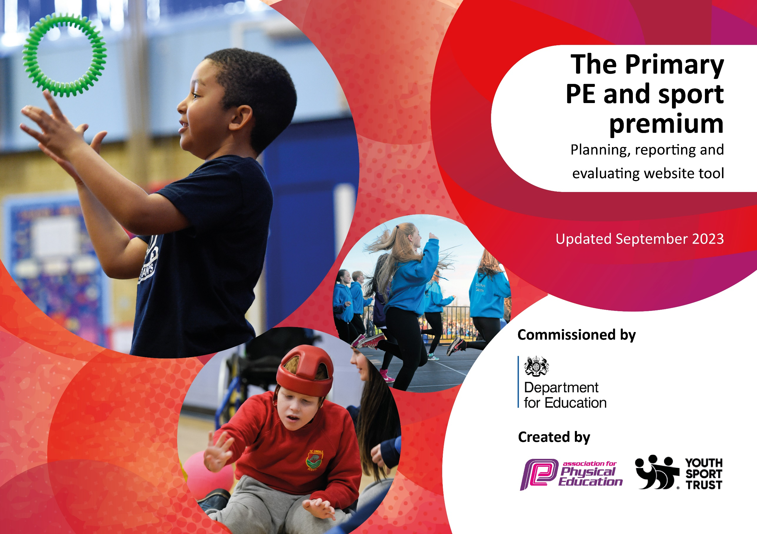

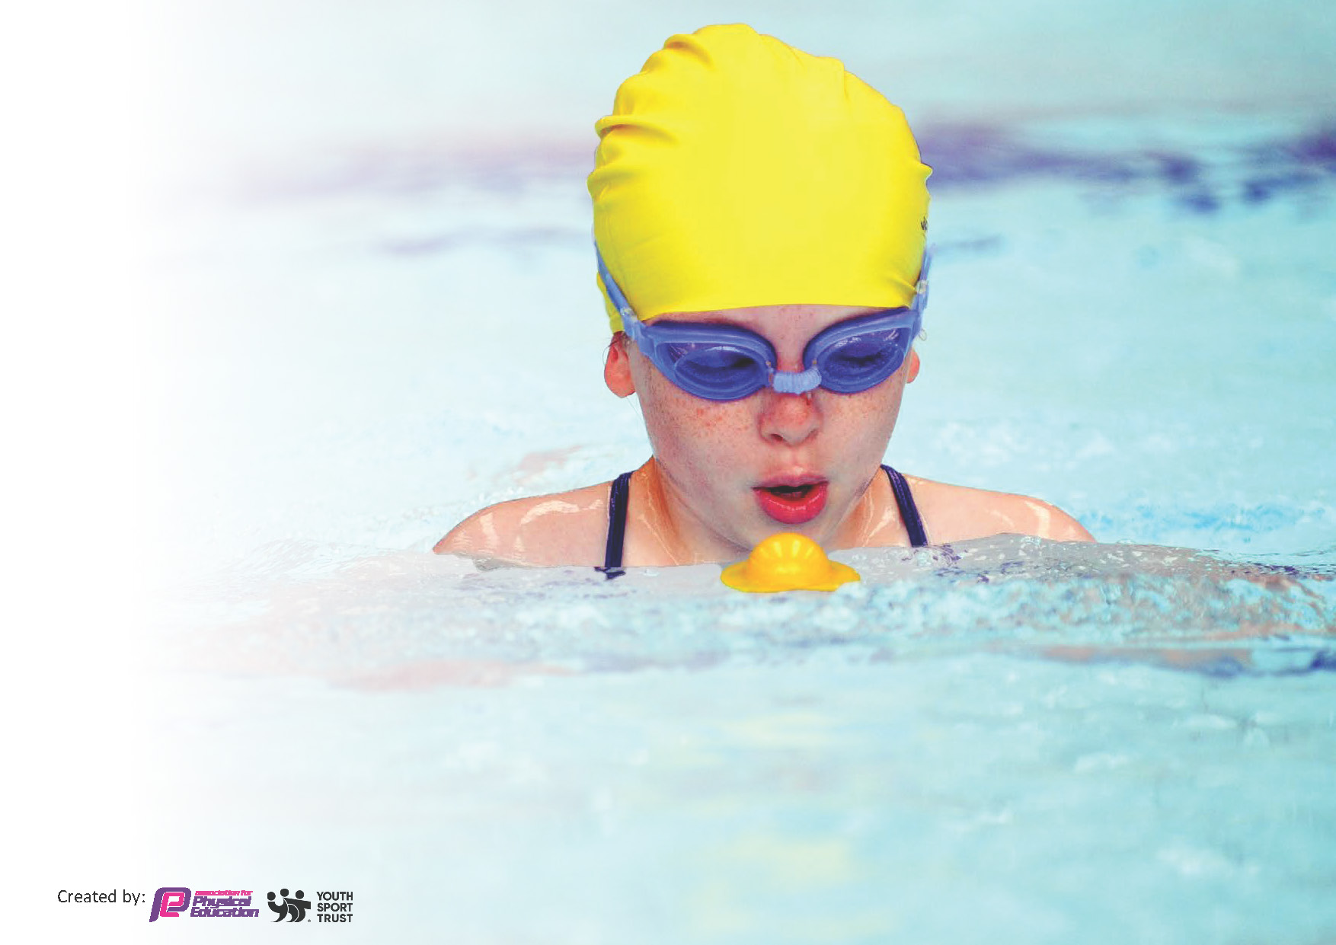
This template can be used for multiple purposes:
by:
- It enables schools to effectively plan their use of the Primary PE and sport premium
- It helps schools to meet the requirements (as set out in guidance) to publish information on their Primary PE and sport premium
- It will be an effective document to support Ofsted inspections enabling schools to evidence progress in Physical Education (PE) and evidence swimming attainment, which forms part of the PE National Curriculum. We would recommend schools consider
the Intent, Implementation and Impact of any spend, as examined within the Education Inspection Framework.

It is important that your grant is used effectively and based on school need.

Schools must use the funding to make additional and sustainable
improvements to the quality of the PE, School Sport and Physical Activity (PESSPA)
they offer. This means that you should use the Primary PE and sport premium to:

- Build capacity and capability within the school to ensure that improvements made now will benefit pupils joining the school in future years
- Develop or add to the PESSPA activities that your school already offers.

The Primary PE and sport premium should not be used to fund capital spend projects; the school’s core budget should fund these. Further detail on capital expenditure can be found in the updated Primary PE and sport premium guidance.

The Primary PE and sport premium guidance, outlines 5 key priorities that funding should be used towards. It is not

necessary that spending has to meet all the key priorities, you should select the priorities that you aim to use any funding towards.

Although completing this template is not a requirement for schools, schools are required to publish details of how they spend this funding. Schools must also outline what the impact this funding has had on pupils’ PE and sport participation and attainment and how any spending will be sustainable in the future. All funding must be spent by 31st July 2025.

The Department for Education has worked closely with the Association for Physical Education (afPE) and the Youth Sport Trust (YST) to develop this template and encourages schools to use it. This template is an effective way of meeting the reporting requirements of the Primary PE and sport premium.
Review of last year’s spend and key achievements (2024/2025)

We recommend you start by reflecting on the impact of current provision and reviewing your previous spend.

Activity/Action | Impact | Comments
Key Indicator 1: Engagement of all pupils in regular physical activity  Achievements:  Children across all year groups accessed a wide range of lunchtime activities, including a bouldering wall, marked running track, and weekly ball court rotations.  Play Leaders and lunchtime staff provided structured physical activity opportunities.  Equipment purchases (e.g. scooters, outdoor play) increased active time during breaktimes and in after-school clubs. | Increased physical activity across all key stages; more children regularly achieving 30 active minutes during the school day.  Children became more engaged through targeted provision and accessible opportunities. | Using our new tracking system to audit children not participating in extracurricular activities has been highly beneficial. It has helped identify those who are not attending after-school clubs, many of whom are Pupil Premium or SEND. By targeting these children, it has become clear that increasing opportunities and tailored activities for these groups should be a key focus for next year.

Key priorities and Planning
This planning template will allow schools to accurately plan their spending.

Action – what are you planning to do | Who does this action impact? | Key indicator to meet | Impacts and how sustainability will be achieved? | Cost linked to the action
To improve the awareness of PESSPA achievements throughout school.  Make the most of the ‘feel good’ effect of sporting success. Allowing children to develop confidence and a positive self-image as they are part of a successful school. | All staff and Pupils | Key indicator 2 - The profile of PESSPA being raised across the school as a tool for whole school improvement | More children wanting to compete in competitions inside and outside of school. Children becoming more confident in other subjects of the curriculum due to there increased confidence. Children and parents recognise the importance of exercise and sport. | Cost part of Shelley Sports Partnership
Children in all year groups have access to a marked running course, new bouldering wall, ball court activities (changed weekly) and daily exercise. Children can also take part in lunchtime activities and Play Leader led competitions.  Increase physical opportunities for all children to get active. Introduce new playtime activities for all children to access.  Portable speaker used to promote dance in the playground at lunchtimes. | Pupils – they will be taking part. Playleaders – Lunchtime supervisors trained in delivering the activity.  Lunchtime Supervisors.  SSCO to train sports leaders | Key Indicator 4 - Broader experience of a range of sports and activities offered to all pupils  Key indicator 1: The engagement of all pupils in regular physical activity – Chief Medical Officers guidelines recommend that primary school pupils undertake at least 30 minutes of physical activity a day in school | Children are more active at lunchtimes.  More pupils meeting their daily physical activity goal, more pupils encouraged to take part in PE and Sport Activities.  Increased participation at lunchtime.  Encourage children to take part in inter school cross county competitions | £9540
To improve skill progression knowledge and confidence in PE, giving teachers an understanding of how to stretch the more able and support and develop the less confident.  Teachers to receive CPD on the Rising Stars scheme. Shane Killock to demonstrate how he would use the scheme and adapt it.  Continue to use the Champions scheme as the backbone of teaching. Ensuring there is a clear progression of skills in each area of PE, allow teachers to utilise their own expertise to achieve this. Use observations to ensure teaching is good or better.  Staff to be aware of available resources to support their planning and delivery.  External coaches delivering PE alongside teacher: rugby, orienteering, athletics, martial arts/fitness, etc. Teachers begin to build their own resource bank of planning, ideas from these observations. | Teachers | Key indicator 3 -Increased confidence, knowledge and skills of all staff in teaching PE and sport | Quality PE lessons and out of school clubs being taught by in house trained teachers. | Cost part of Shelley Sports Partnership
To ensure that all teachers have access to equipment that means all children have access to engagement in PE lessons, playtimes and extra-curricular clubs.  To provide scooter out of school club and lunchtime activity.  Increase play in reception by creating a sandpit and a wild area around school. | Teachers, delivering activities. Lunchtime supervisors. | Key indicator 1 - The engagement of all pupils in regular physical activity – the Chief Medical Officer guidelines recommend that all children and young people aged 5 to 18 engage in at least 60 minutes of physical activity per day, of which 30 minutes should be in school.  Key indicator 4: Broader experience of a range of sports and activities offered to all pupils. | More pupils meeting their daily physical activity goal, more pupils encouraged to take part in PE and Sport Activities. | £1628  £1318  £707
Increase participation in competitive inter-school competition.  Travel to inter school competitions to increase competitive participation during school time for all children.  Continue to participate in the Shelley Schools Sports partnership as it offers such good value for money,  Additional funding for all children to access inter school competitions. | Teachers and ETAs to facilitate these competitions.  SSCO – organized events | Key indicator 5: Increased participation in competitive sport | 100% of our children will have the opportunity to take part in competitive sporting events throughout the year.  Create a positive profile for sports competitions through assemblies, newsletters, social media, school notice boards and teacher input. This will inspire children to be involved.  Staff will offer their time to attend events maximising our ability to enter all competitions. Enter competitions at B and C level whenever possible so the less able can also take part. | Cost part of Shelley Sports Partnership

Continue to buy into the Shelley Pyramid Sports Partnership, in order to access sport coaches, competition, CPD and the development of pupils, i.e. Play Leader training. Provide further support, as needed, to maintain the provision once funding has been removed. | All Teachers | Key Indicator 1: Increased confidence, knowledge, and skills of all staff in teaching PE and sport.  Key indicator 5: Increased participation in competitive sport. | Primary teachers more confident to deliver effective PE supporting pupils to undertake extra activities inside and outside of school, including teaching water safety and swimming and as a result improved % of pupil’s attainment in PE. | £4878

Key achievements 2023-2024
This template will be completed at the end of the academic year and will showcase the key achievements schools have made with their Primary PE and sport premium spending.

Activity/Action | Impact | Comments
CPD for staff through coaches and forest schools.  Scooter equipment bought to provide scooter activities in all year groups as well as after school clubs.  SSCO subscription. School games competitions.  Clubs in sports such as tennis, athletics and boxercise.  Engage in sports week. SEND festivals. PE lessons are twice a week. Outdoor equipment taken out. Brain breaks to be active. Sports clubs. | Key indicator 3: Increased confidence, knowledge and skills of all staff in teaching PE and sport.  Key indicator 4: Broader experience of a range of sports and activities offered to all pupils  Key indicator 3: Increased confidence, knowledge and skills of all staff in teaching PE and sport.  Key indicator 5: Increased participation in competitive sport  Key indicator 2: The profile of PESSPA being raised across the school as a tool for whole school improvement  Key indicator 1: Ensuring that children engage in at least 30 minutes of regular physical activity a day in school, outside of PE lessons. | Staff felt confident and lessons show better progression and understanding.  Children had wider opportunities to take part in a range of sports through extracurricular activities.  Staff had support through the scheme. Diagrams, videos and key knowledge provided.  Children understanding competition and aiming to improve.  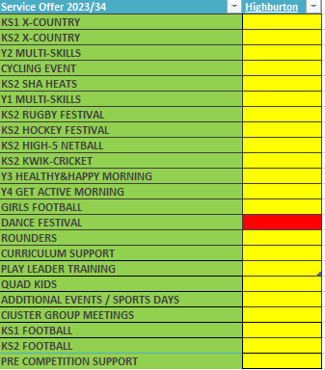  Children becoming more engaged through precise targeting of pupils to engage. Children are able to be physically active 30 minutes per day in a range of ways.

Swimming Data 2022/23
Meeting National Curriculum requirements for swimming and water safety.
Priority should always be given to ensuring that pupils can perform safe self-rescue even if they do not fully meet the first two requirements of the National Curriculum programme of study

Question | Stats: | Further context  Relative to local challenges
What percentage of your current Year 6 cohort can swim competently, confidently and proficiently over a distance of at least 25 metres? | 100% (Year 5 Cohort)
What percentage of your current Year 6 cohort can use a range of strokes effectively [for example, front crawl, backstroke, and breaststroke]? | 86% (Year 5 Cohort)

What percentage of your current Year 6 cohort are able to perform safe self-rescue in different water-based situations? | 50%
If your schools swimming data is below national expectation, you can choose to use the Primary PE and sport premium to provide additional top-up sessions for those pupils that did not meet National Curriculum  requirements after the completion of core lessons. Have you done this? | Yes/No
Have you provided CPD to improve the knowledge and confidence of staff to be able to teach swimming and water safety? | Yes/No

Signed off by:

Head Teacher: | Graham Booth
Subject Leader or the individual responsible for the Primary PE and sport premium: | Graham Booth
Governor: | Neil Hollis
Date: | 15.7.24

